MACH4METAL

metalworking machinery
Transito 21, 6909 DA Babberich, Netherlands
Tel. + 31 (0)316 – 247123
Fax. + 31 (0)316 - 247956

Bank No : 66.52.13.883
IBAN : NL33 INGB 0665 2138 83
BIC : INGBNL2A
VAT : NL 815393635B01

EST Ticino ET 520 x 2000 mm

- Make : EST Ticino
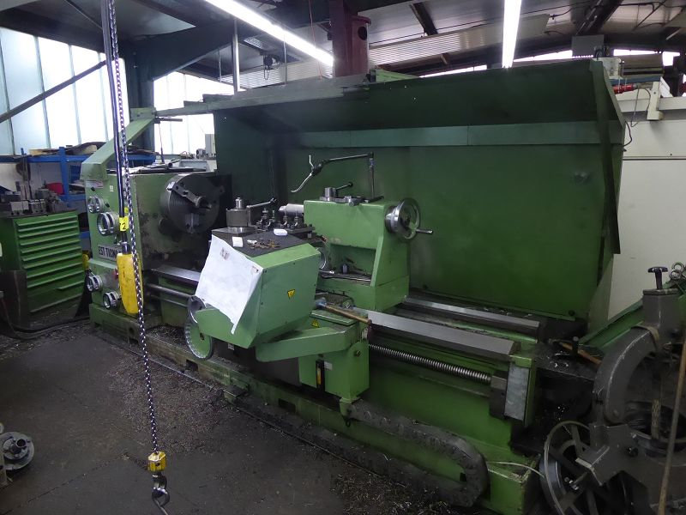
- Type : ET 520
- YOP : 1988
- Serial : 0099..

- Swing over bed Ø : 1.040
- Swing over support : 710
- Centre distance : 2.000

- Spindle bore : 130
- Bed width with double prism : 600
- Length of the main-slide guides : 900
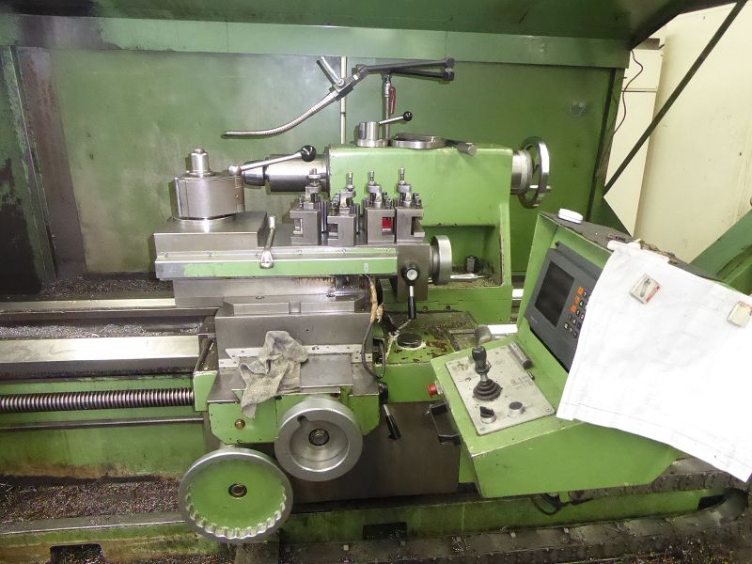
- Cross slide width : 770

- Diameter tailstock spindle : 130
- Travel Manuel quill : 300
- Morse taper : Mk-6

- Work piece weight in chuck : 3.200
- Work piece weight b. centres : 8.500

- Motor power Pk : 35
- Rapid movement X mm/min. : 4.000
- Rapid movement Z mm/min. : 2.400
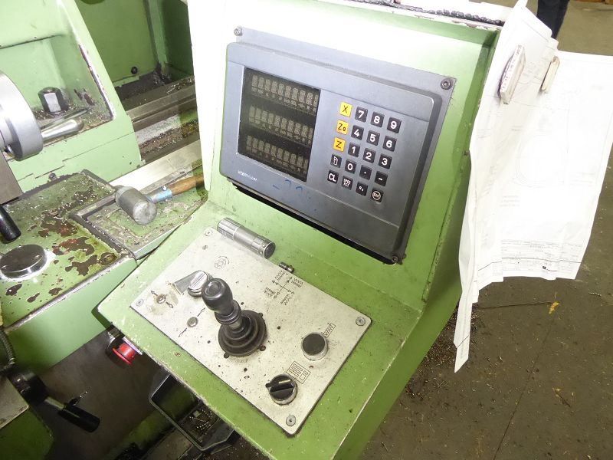
- Speed range Rpm : 600

- Dimensions:
- Length bed : 5.500
- Width : 2.350
- Height : 1.550
- Weight : 8.600

- Central lubrication
- Build from <Meehanite> cast iron
- Hardened and ground guide ways

Please Note: The above information has been obtained to the best of our ability and belief from, and from the manufacturers where possible. It is given in good faith, but its accuracy can not be guaranteed. Accordingly, it will not form a representation or constitute contractual terms. We advise you to check any vital details!

